**CADENAS and Missler Software announce the availability of manufacturer catalogs based on CADENAS PARTcommunity technology directly in TopSolid**

Users of the CAD/CAM software TopSolid will be able to access millions of standardized components and suppliers, without changing the system – reaching unprecedented levels of productivity

**Germany, Augsburg, 2nd November 2016.** The direct connection between manufacturer catalogs of CADENAS and the TopSolid interface will enable companies to rapidly optimize the design of their products by reducing the time spent searching for standard components.

This new integration benefits companies increasingly looking to reduce the time to market of their products. By providing excellent-quality 3D CAD models, approved and certified by their suppliers, directly into TopSolid via a web service, CADENAS and Missler Software allow designers to produce their projects more quickly.

This means that customers will be able to retrieve 3D CAD models of products from library, with their metadata and bill of material, and automatically integrate them into the TopSolid PDM tool.

**The manufacturer catalogs of CADENAS PARTcommunity are available directly in TopSolid from version 7.10.**

“We have worked with CADENAS for many years, and our customers were asking for direct access to component libraries in TopSolid. It is a pleasure to announce that this is now available,” said Dominique Laffret, VP Strategic Partnerships at Missler Software.

“This partnership fits in perfectly with our goal of helping designers from around the globe create their CAD projects more quickly and efficiently. The direct interface in TopSolid takes things a step further,” added Pascal Bottet, Managing Director of the French subsidiary of CADENAS.

**Press Images:**

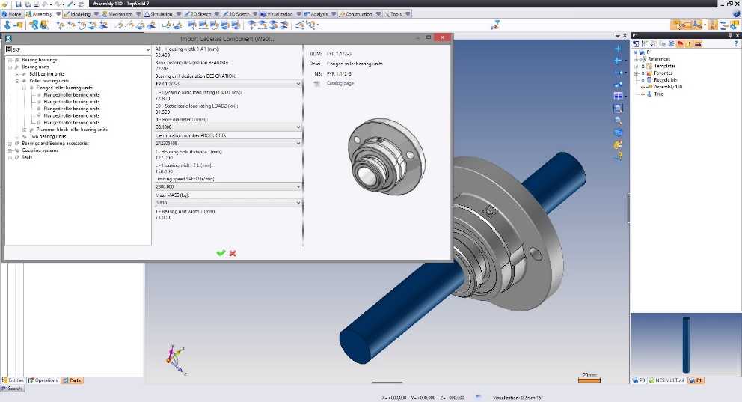

**Caption:** This new integration of PARTcommunity manufacturer catalogs in TopSolid benefits companies increasingly looking to reduce the time to market of their products.

This press release and accompanying images are available for download from our website: [www.cadenas.de/press/press-releases](http://www.cadenas.de/press/press-releases)

**About CADENAS**

CADENAS is a leading software developer in the areas of Strategic Parts Management and parts reduction (PARTsolutions), as well as Electronic Product Catalogs (eCATALOGsolutions). With its customized software solutions, the company acts as a link between the component manufacturers with their products and the purchasers.

With its 300 employees at 17 international subsidiaries, the name CADENAS (Hispanic: process chains) has been standing for success, creativity, support and process optimization since 1992.

For further information, please visit: www.cadenas.de/en